Thermal Label Printer RP80VI

User Manual

Content
Content 2
1．instruction 3
1.1safty warnings 3
1.2notices 3
2．SUMMARISATION 4
2.1main features 4
3．specifications 4
4. printer INSTALLATION and operating 6
4.1the dismantle of the printer 6
4.2 the connectopm of the printer 6
4.3 the loading of the paper 7
4.4the boot function of the printer 8
4.4.1 the gap sensor calibration 8
4.4.2 printer initialization 8
5. Indicators and Keys 9
5.1 indicators 9
5.2 fault code 9
5.3 keys 10
6. The serial interface of the printer 10
7. the parallel interface of the pritner 11
8. the ethernet interface of the printer 12
9. the cash port of the pritner 12
10. the friver of the printer 13

1. Instructions
RP80VI series is thermal barcode printer with high performance and reliability. It is with high quality and competitive price and easy to use, so it is widely used in the factory, logistics, restaurant, tea shop, etc.
Safety Notices
Please read the below warnings carefully and observe it strictly before operating the printer.

1.1safety warnings
Warning: Do not touch the printer cutter or paper tearing cutter.
Warning: The print head is the head and the peripheral comp finishing the printing.

1.2 Notices
(1) The printer should be put on solid place. Don’t put printer on vibration and shocking place.
(2) Don’t print or save printer in high-temperature, high-humidity and heavily polluted place.
(3) Printer adapter should be connected to a properly grounded socket. Don’t use the same socket together with large motors or other equipment that may cause voltage fluctuations.
(4) Avoid water or conductive material (such metal) going into the inside of
the printer, once happen, should turn off the power immediately.
(5) If long time not uses printers, should disconnect the adapter power.
(6) Don't disassemble the printer for overhaul or transformation.
(7) Please only use the adapter, which is together with printer
(8) To ensure the quality and lifetime of printer, we recommend to use high-quality thermal paper and ribbon.
(9) Make sure the printer power is turned off when Pull or plug connection lines.
(10) When Pull or plug power cord, please hold at the cord end, which is marked with arrow (do not pull the soft part of the cord) .
(11) Please keep this manual for reference.

2. SUMMARISATION

2.1Main Features
● Support thermal paper roll/thermal sticker/thermal label
● 2-6inch/s high printing speed
● Support 2D printing (QRCODE)
● Paper width from16mm-82mm and easy to use
● Adjustable pressure of the printing head
● Paper automatic checking function
● Modular design to meet different application requirements
● Self-adaptive temperature control
● Low power consumption and low running costs

3. Technical parameters
● Printing method: Direct thermal printing
● Resolution: 203DPI
● Printing width: 80MM （max）
● Printing speed: 150mm/s (max); 127mm/s (normally)
● Memory: DRAM: 8M FLASH: 4M
● Interfaces
USB interface: General USB interface (standard type B).
Serial interface: DB9 female interface, baud rate of 4800bps, 9600bps, 19200bps or 38400bps optional (via DIP switch adjustments), data structures for no parity, 8 data bits, 1 stop bit, supports RTS / CTS and XON / XOFF handshaking meeting.
Ethernet interface: Standard RJ45-8P interface, 10M / 100M adaptive transmission speed, 100M LED indicates network, data communication LED indicator.
Cash drawer port: Standard RJ-11-6P socket, output DC 24V / 1A power supply signal to drive the cash drawer action.
● Different type of interface panel are as following
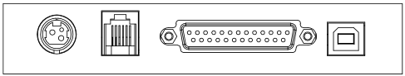 RP80VI-UP:
Power port Cash drawer Parallel interface USB
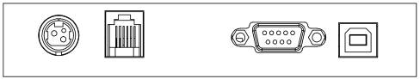 RP80VI-US:
Power port Cash drawer Serial interface USB
RP80VI-USE:
Power port cash drawer Ethernet interface Serial interface 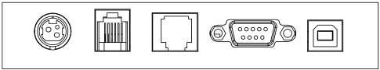 USB
● Barcode:
1D code: CODE128、EAN128、CODE39、CODE93、EAN13、EAN8、CODABAR、UPCA、UPCE、MSI、MSIC、I25
2D code: QRCODE
● Medium
Paper type: thermal paper roll, stickers, etc.
Paper width: 16mm-82mm
Diameter of the outside paper roll: 85mm Max
Paper-out method: automatically stripped or peeled off
● Power adapter of the printer:
Adapter input voltage: AC 110V/220V，50〜60Hz
Adapter output voltage: DC 24V/2.5A
Printer input voltage: DC 24V/2.5A
● Weight of the Printer: 1.36kg (paper roll not included)
● Sizes:
237(L) x 146(W) x 130(H) mm
● Environment:
Working temperature: 5~45°C; Working humidity:20-80%RH(Non-condensing)
Storage temperature: -40〜55°C; Storage humidity: ≤90%(Non-condensing)

Printer installation and operation

4.1 The dismantle of the printer
Check the spare parts
Please check the spare parts when opening the box, please contract the supplier or factory if anything missed.
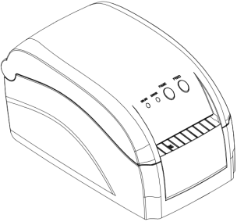printer | 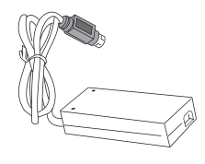power adapter | 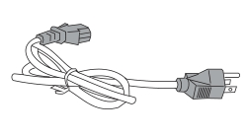power cord
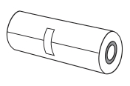paper roll | 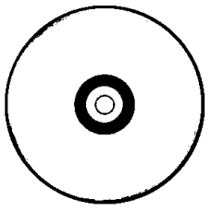CD | 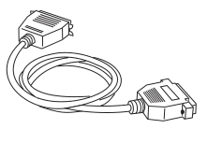cable

4.2 The connection of the printer
(1) Make sure that the printer and PC are turned off, connect the cable to printer and the interface (Serial/Parallel/USB/Ethernet) of the equipment.
(2) If the automatic cash drawer is available, then connect the RJ-11 of the cash drawer to the cash drawer port of the printer.(the specification of the cash drawer must coincide with the driver of the printer’s cash drawer)
(3) Connect the dedicated adapter of the printer
Please use the dedicated adapter of the printer. Connection diagram is shown below:

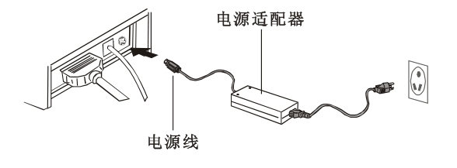

Attention:
(1) First plug the DC24V power cord of the printer, and then plug the AC220V power, at last turns the power switch. Do not do that opposite way, or it will do harm to the printer.
(2) Inappropriate use of the power adapter will lead to bad quality printing, or even do harm to the printer.
(3) Do not connect the telephone line to the cash drawer port, or it will damage both the printer and the telephone.
(4)When pull the power cord of the printer, please hold the pace where signed arrow (Do not hold the soft cord to pull the power cord). Hold the soft cord and pull may damage the printer or the power adapter.

4.3 The loading of the paper roll
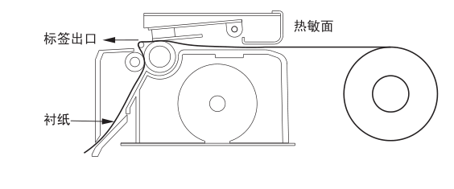Detailed operation as shown below:
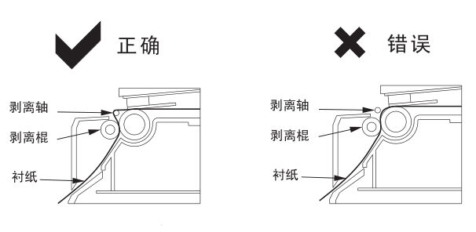

4.4 Function of Starting Up

4.4.1 Interval Sensor Adjusting
It is necessary to adjust sensitivity of interval sensor under the situation below:
- new printer
- change label
- Printer initialization
This function is for testing sensitivity of interval sensor. When users change paper of different specification or initialize printer, it needs to set up the interval sensor adjusting.
Please follow up the steps below to adjust interval sensor:
- turn off the power of printer
- make sure the paper exists and cover is closed
- press the PAUSE button and turn on the printer, when printer open interval sensor adjustment, loosen PAUSE button.

4.4.2 Printer Initializing
This function is for clearing data downloaded in DRAM and resetting the printer. Please start adjustment of interval sensor after initialization.

5.Indicator Light and Button
There is tow indicator lights: blue light for power and red light for error. Tow button: PAUSE and FEED. Showed as follows:

5.1 Indicator
S/N | Status | Function Declaration
1 | Power light normally on, error light off | Normal
2 | Power light normally on, error light on | Error and refer to fault code

5.2 Fault Code
Code | Buzzer Hint | Function
1 | 1 beep when printer is on | Initialization is finished
2 | 2 beep successively | Mechanism disconnect
3 | 3 beep successively | No paper/error
4 | 4 beep successively | Cutter is in error
5 | 5 beep successively | overheated
6 | 6 beep successively | Not heat
7 | 8 beep successively | Black mark detection error
8 | 9 beep successively | External RAM is in error in detection
9 | 10 beep successively | External FLASH is in error in detection

5.3 Button

Serial No. | Function | Description
1 | Feed | While power light is on,and ERROR light is off,when press FEED button,printer can feed to the front of next label paper.
2 | Pause | When the printer is working,if press PAUSE button,the printer will stopping working.
3 | Gap sensor calibration | 1.Close printer power  2.Make sure printer is feed paper and cover the upper cover.  3.Press on PAUSE button,and open printer power,now printer will automatic calibrate the sensitivity of gap sensor and then save the parameters into memory.Finally,loosen PAUSE button.
4 | Access debug mode | 1.Close printer power.  2.Make sure printer feed paper,and then cover the upper cover.  3.Press on PAUSE and FEED buttons simultaneously,then open the power,when power light(Blue) and ERROR light(Red) are on simultaneously,loosen PAUSE and FEED buttons,now printer is in debug mode

6. Printer Serial interface

RP80VI Printer Serial interface is RS-232 standard,communication baud rate is 4800bps、9600bps、19200bps or 38400bps optional (you can adjust it by DIP switch),8 data bits,without odd and even number validation,one stop bit,support RTS/CTS and XON/XOFF Handshake Protocol.

Printer serial interface,the definition of each pin function is as follows:

Pin no. | Model name | Signal source | Description
2 | TXD | Printer | When use XON/XOFF handshake protocol,printer will send control code XON/XOFF to host.
3 | RXD | host | Printer will receive data from host
7 | RTS | Printer | The signal response current printer state,Low level shows printer is busy,it can not receive date.while high level shows printer is ready,and it can receive data.
5 | GND | -------- | Signal Ground
4 | DTR | Printer | It is same as RTS signal(PIN 7)

The Connection diagram between printer serial interface and POS host serial interface:

TXD 2 2 RXD
RXD 3 3 TXD
RTS 7 8 CTS
DTR 4 1 DCD
GND 5 5 GND
6 DSR
Printer serial interface DB9 4 DTR
POS host serial interface DB9

7. Printer parallel interface
RP80VI printer parallel interface socket is 25PIN Parallel socket,8 bits parallel transmission,support BUSY/nAck handshake protocol.Each PIN function of Printer parallel interface socket are as follows:

PIN no. | Signal name | Signal source | Description
1 | /STB | Host | Data gate trigger pulse,it will read-in data when negative edge
2  3  4  5  6  7  8  9 | DATA2  DATA3  DATA4  DATA5  DATA6  DATA7  DATA8  DATA9 | Host  Host  Host  Host  Host  Host  Host  Host | These signals separately represents NO.1 to No.8 information of Parallel data.And when logic is 1,it is high level,when logic is 0,it is low level.
10 | nAck | Printer | Printer answering signal,It shows printer has received previous byte data
11 | BUSY | Printer | High level shows printer is busy,it can not receive data
12 | GND | ----- | ground connection,Logic low level
13 | Select | Printer | By resistance to pull high level
18-25 | GND | ----- | Ground connection,logic low level
15 | NError(nFault) | Priner | Printer ERROR singal

Printer Ethernet Port

The Ethernet interface socket of RP80VI is RJ45-8P, supporting 10M/100M network, and the transmission speed is adaptive.

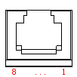

Pin No. | Description | Instruction
1 | TX+ | Send differential  line+
2 | TX- | Send differential  line -
3 | RX+ | Receive  differential line+
4 | NC | No function
5 | NC | No function
6 | RX- | Receive  differential line -
7 | NC | No function
8 | NC | No function

9. Printer Cash Drawer Port
The printer cash drawer port is with standard RJ-11, 6-wires socket, output DC 24V/1A and work by power signal. Plug the RJ-11 crystal plug into cash drawer port and then you can open the cash drawer via printer.
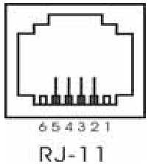

Printer cash drawer interface pin functions are defined as follows:

Pin No. | Signal | Flow Direction
1 | Empty | Empty
2 | Structure ground | Output
3 | Empty | Empty
4 | Cash drawer  driver signal | Output
5 | Empty | Empty
6 | Empty | Empty

10、Printer driver
Two types of drive for RP80VI Series: one is to install driver program directly under Windows9x/ ME/ 2000 /XP, the other is to install drive through Serial, Parallel, USB or Ethernet.
- Install driver under Windows
Add printer in the Windows, and appoint the driver documents in the driver disk to Windows. It can print once you start print command in the program. In this way, windows printer driver turns characters to graphics dot-matrix for printing.
- Install driver by Interface
In this way, no need for drive program. It can print just when it output character to port and the hard font inside printer realizes the character exchange printing. By port for driver, the printing type transforms page printing to line printing, which controls printing more conveniently.

